**Important Instructions:**

* Please read the document thoroughly before you code.
* Import the given skeleton code into your Visual Studio.
* Do not change the Skeleton code or the package structure, method names, variable names, return types, exception clauses, access specifiers etc.
* You can create any number of private methods inside the given class.
* You can test your code from main() method of the program

**Time: 2 hours**

**Assessment Coverage:**

* Classes and Objects
* ADO.NET

# **Requirement 1:**

**Problem Statement: Booking Flight Ticket**

You are required to develop a C# console application to book a flight Ticket and store it in DB.

**Please find below the table structures for reference:**

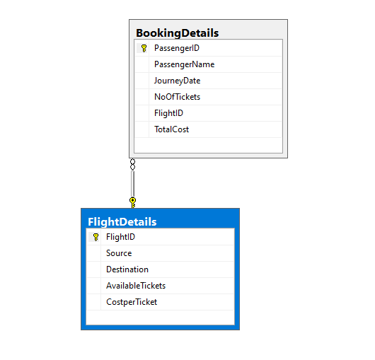

**Requirement 1:** Create a public class with the following properties.

**Class Name: DALFlight**

|  |  |
| --- | --- |
| **Method Signature** | **Description** |
|  |  |
| public static DataTable GetFlightDetails() | Create a Method called “GetFlightDetails” which returns the DataTable of Flight Details from the “FlightDetails” table of the Database. |
|  |  |
|  |  |
| public static bool ValidateAvailability(int FlightID, int NoOfTickets) | Create another method “ValidateAvailability” which accepts the FlightID and the Number Of Tickets which the user wants and checks the availability of the tickets from the database and returns a Boolean value of “true” if the tickets are available. |
| public static int AddBooking(int pid, string pname, DateTime Jdate,int Noft, int fid) | Create another method “AddBooking” which accepts the Passengerid, PassengerName, Date of Journet, Number of Tickets and the flightID and calculates the total charges and stores the details in the “BookingDetails” Table in the Database. |

**Requirement 2:** Create a public class with the following properties.

**Class Name: BALFlight**

|  |  |
| --- | --- |
| **Method Signature** | **Description** |
|  |  |
| public static DataTable GetFlightDetails() | Create a Method called “GetFlightDetails” which returns the DataTable by invoking the DALFlight GetFlightDetails method. |
|  |  |
|  |  |
|  |  |
| public static int AddBooking(int pid, string pname, DateTime Jdate,int Noft, int fid) | Create another method “AddBooking” which accepts the Passengerid, PassengerName, Date of Journey, Number of Tickets and the flightID and passes the same to the AddBooking method of the DALFlight Class. |

**Requirement 3:** In the Main Program, Display the Flight Details using the “GetFlightDetails” method of the “BALFlight” class. Get the following details from the User (PassengerID, Passenger Name, Date of Journey, Number of Tickets, FlightID) and calculate the total charges and insert the Booking Details into the database using the “BALFlight” class’s “AddBooking” method. The sample output is shown below:

**Sample I/O 1**

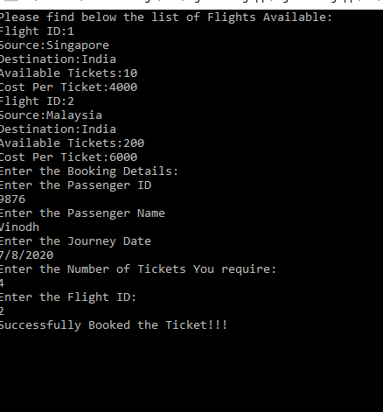

**Sample I/O 2**

